Full day journey
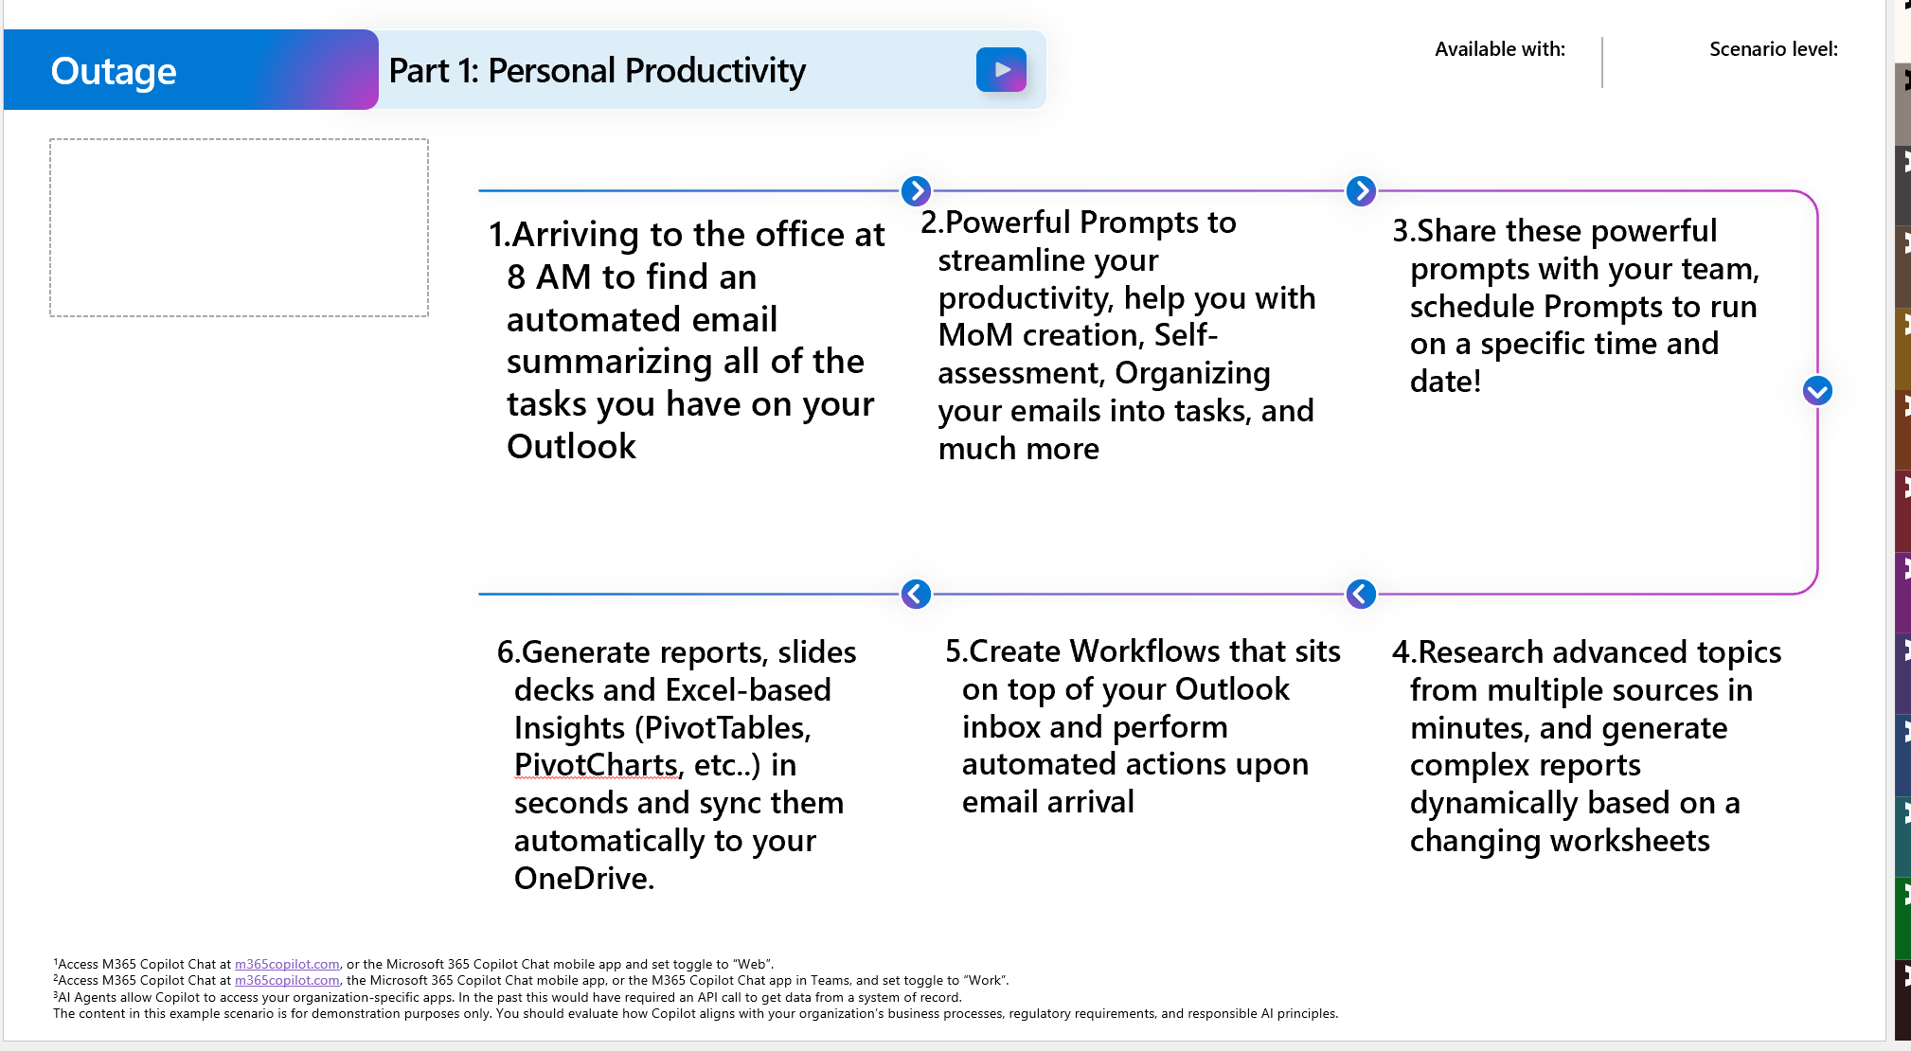
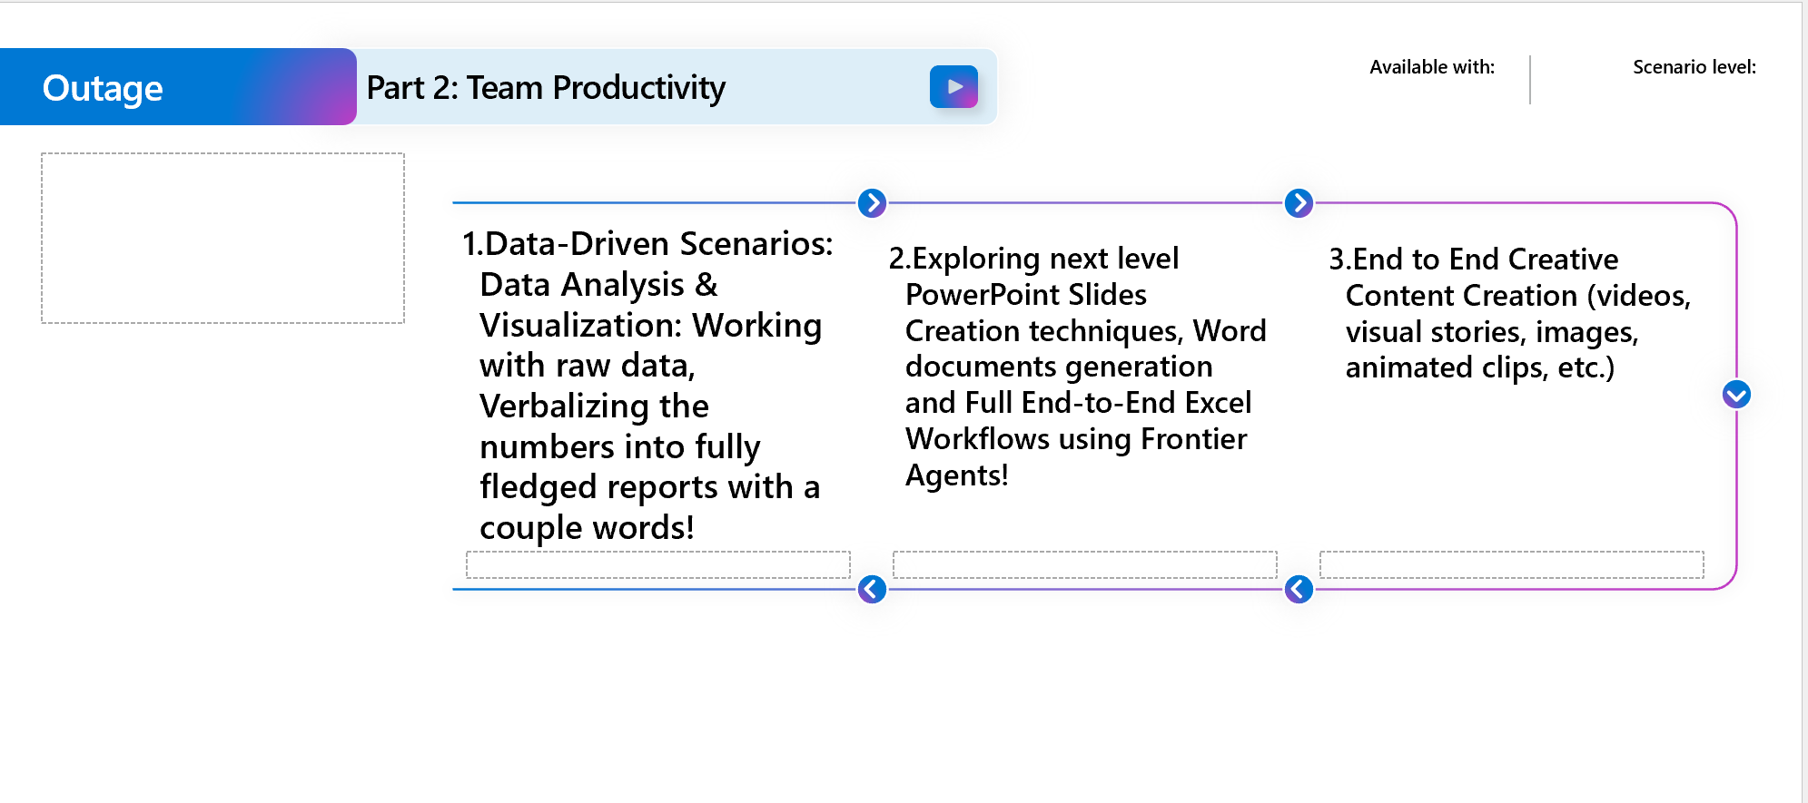

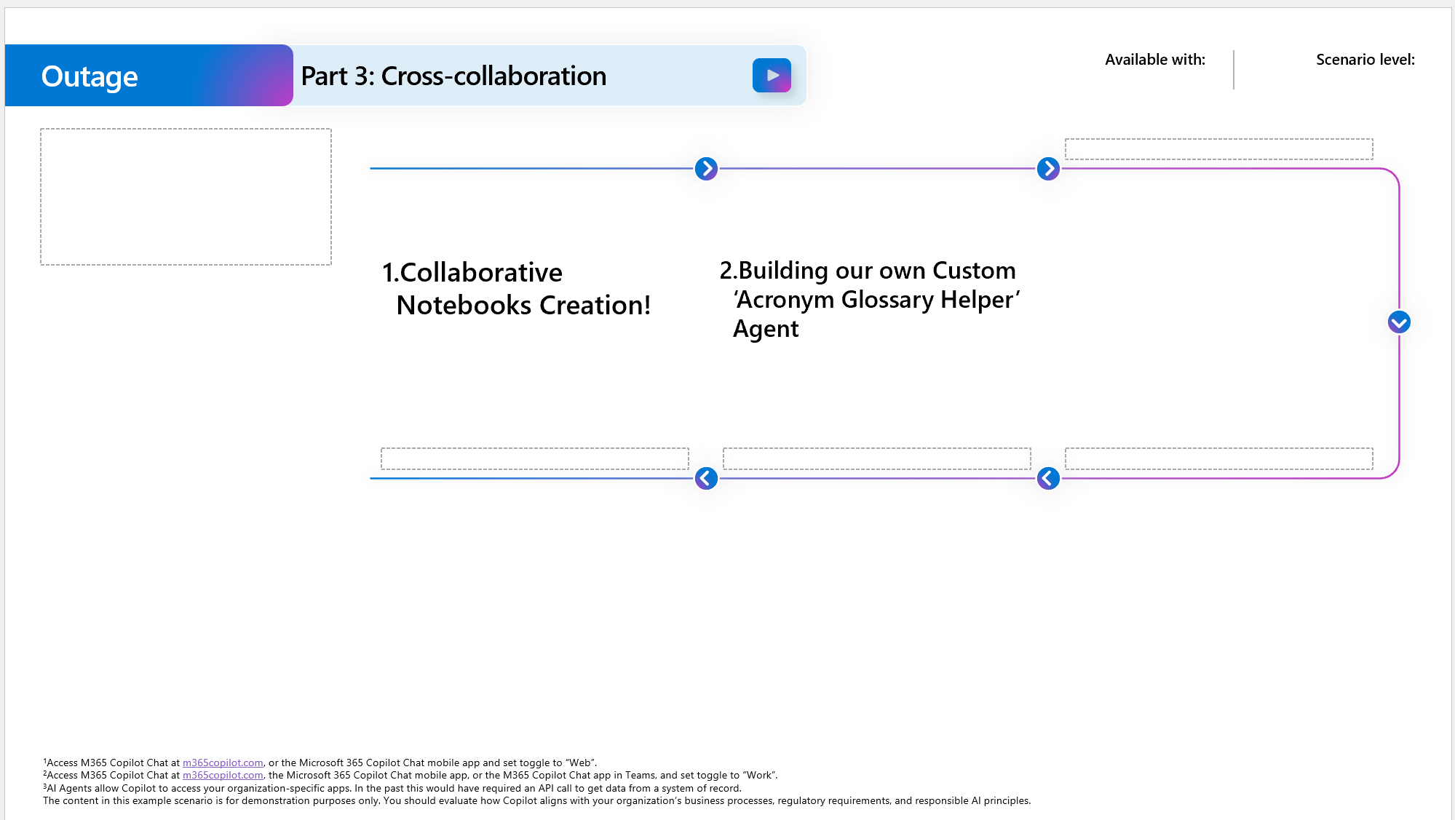
Full day script (M365 copilot features to be illustrated in the demo)
Search (example prompts)
    - The pre outage excel file
    - all files on U2Rf03

Instructor's Custom Instructions for Copilot chat

Do not sound AI; sound more human.
Use a formal tone
DO NOT USE EMOJIS.
Avoid technical jargon unless it is essential for decision-making.
If any technical abbreviations are included, explain it.
Prioritize insights on performance, market dynamics, and leadership Always be ready to follow up with an ask regarding creating a draft of the response for outlook emails.
Prepare the response to fit the context: Based on the destination (HR, IT, Leaders, Executives, etc..) that this draft will be sent to, prepare a suitable format accordingly.
Make sure the tone matches my usual tone and personality.
If I'm working on scientific papers or research, make sure the generated draft is following the same writing approach.
Always be ready to follow up with an ask regarding transforming the listed response into a table format.
Always give sources that lead to your response and original author.
When your response has results from the internet, follow up with a suggested prompt which on execution, prepares two categories: one for internal findings and another for internet findings.
When you're not sure of your answer give me the name of multiple subject matter experts within my organization who I should ask based on their expertise on the subject I ask.
Use recent and reliable internet sources to dig in for more information on the subject.
Share clear and truthful feedback in a respectful tone, and focus on offering constructive suggestions when something needs improvement.

Powerful Prompts:

Outlook Digest:
Scan the emails in my Outlook inbox from the last week and sort each message into the table below. For every entry, include a direct link to the email and specify the justification for its placement under one of these categories: To-Do, OnGoing, Delegate (And specify the individual or team I can delegate this task to), Can be deleted. Also mention which email/task has priority to be finished within the ongoing week and which ones can wait.

Prompt automation + Notifcation via email
Prompt Sharing into Teams teams
Prompt Saving

schedule a meeting with me and William today for 1 hour to talk about the new sustainability project - find an hour where both of us are available

[Probation Self-assessment]
look up all my teams messages and chats from the previous 3 months, Create a two categorizations, the first outer categorization is by the person who I have spoke to, the second inner categorization is by the topics that I have conversed with that person. Within each topic, I want you to list 3 things: brief of the topic we discussed, the files that we exchanged (if exists) with their source pin, and the links that we have exchanged (if exists) I just got hired (3 months ago) and im in my probation period (9 months), every engagement with my team/collogues is important to me. Tell me which of those topics (and mention the person I have conversed with) I didnt respond, or I was reactive or negative, suggest how I could have been more proactive and a future behavioral advice that I should do in the future to help leave a lasting positive impression about me. Remember this because I will come after 3 months and I will ask you to reassess my behavior and the way I was engaging with the others

[L&D]
Compare the employee satisfaction survey results from the 2024 and 2025 reports Employee_Satisfaction_Report_2025, Employee_Satisfaction_Report_2024 .Using this external reference as extra context: [https://www.cipd.org/uk/the-people-profession/the-profession-map/explore-the-profession-map/special…]. Focus on satisfaction percentage, training participation rates, and recognition feedback. Present your findings as follows: (1) a table summarizing key metrics side-by-side, (2) a concise narrative highlighting major changes and trends for management review, and (3) three recommended visualization types (e.g.: "Clustered Bar – Key % Metrics", "Radar – Driver Scores", "Diverging Sentiment – Themes", etc..) to best illustrate the results.

Activity 1:
[Solution] Prompt coach
Help me write a prompt that can generate a similar output exactly as the one in this file MoM Benchmark 1.docx

Summarize this meeting into a professional Word document that captures the full context, key discussion points, decisions made, action items, and any follow-ups. Structure the output with clear headings, bullet points, and tables where appropriate. Ensure the tone is formal and business-ready, suitable for sharing with stakeholders. Include:
- Meeting Title and Date
- Attendees (with roles if available)
- Agenda Overview
- Discussion Summary (grouped by topic)
- Decisions Made
- Action Items (with owners and deadlines)
- Assigned Tasks with Assignees
- Questions that should have been asked (per attendee with mention to role)
- Questions that should have NOT been asked and is suitable for internal meetings only
- Next Steps or Follow-ups
- Any referenced files or links
Use information from the meeting transcript, shared files, and chat messages. Format the document for clarity and readability

Copilot in Outlook

Activity 2:
[Solution] idea coach:
Based on my email/thread interactions, people and projects I'm engaging with, and topics in my outlook mailbox, and given the following preferences I usually prioritize when writing any draft emails:
- To sound like my tone, level and way of writing
- to be concise and to the point
- to avoid branching in topics
- to write all my arguments/points of discussion in ordered list format
- to end all my emails with 'feel free to come back to me/do not hesitate to contact me for any clarifications'
Help with drafting some ideas accordingly that I can use to generate my own customized draft instructions for outlook

Instructor's draft instruction
Dear {name}, I hope you are doing great!
[if this is a message that is a thread starter then make sure to start with the following phrase]
I'm writing you this email to {topic to be discussed}
[if this is a reply, then make sure to reply with something in the lines of:]
Thank you for your {feedback/email}. I would like to follow up on the upcoming points: [breakdown the asks in the email into separate ordered list and tackle them one by one]
[End with a warm tone and a sincere greeting]
[Refer to my inbox and emulate my personality in the email and my writing style]
[Always state with a message that you are welcoming any kind of asks/inquiries and you are open to provide help as needed]
[if I ask you to draft a email to congratulate someone, include emojis and exclamation marks]
[if my mail was directed towards my manager, then make sure by direct and concise in the draft to give the needed summary within 2-3 lines]

Copilot in Teams

Researcher
Use Case 1: Acronym List creation
i will create a glossary agent used for acrynom explanation, based on the acrynoms from the excel sheets (attached) U2RF03 report rev7 19-01.xlsx Comprehensive Pre Outage List (Each Unit Last Outage).xlsx
Create a full acronym list with their abbreviation and explanations so that I can feed it to an M365 Agent builder agent's instructions, where the end user can use that agent for the acronym meaning
Your output format expectation should be text format that covers the following (For each acronym):- Code - Category- Meaning / Explanation
- Where it appears - Notes/What to doAn example of what a real output should look like: (emulate this example - do not use the values below as factual statements)- Code: CM - Category: Dashboard classification - Meaning/Explanation: Work order type bucket derived from SAP Order Type prefix. - Where it appears: U2RF03 'Data' sheet column 'WO Type' - Notes/What to do: Use to group PM vs CM vs ST vs PT in reporting.
- Scan the entire contents of both files 2. Infer 3. No dont inlcude duplicates
Make sure your text output does not exceed 6000 to 70000 characters.

Use Case 2: Tevfik Cetin
Researcher Prompt:
- Act as head of Outage Operations of ENEC Barakah Nuclear Power Plant and prepare an action plan to reduce the unplanned downtime and improve efficiency. Do not make up information. Use trusted and verifiable sources only.
After completion of this prompt, do the same for planned outages.

2. Act as head of Outage Operations of ENEC Barakah Nuclear Power Plant and prepare an action plan to reduce the planned and unplanned downtime and improve efficiency. Do not make up information. Use trusted and verifiable sources only.
Outage Operations in Barakah is managed by 4 Streams. Below are the process definitions of these streams. Use this information in your analysis. Provide improvement points for each stream.
- Preparation/Scope Stream
Process: Teams extract information from SAP and other tools (e.g., Markers) to confirm material availability, check functional locations, and identify required materials for specific scopes. Example: Ahmad described starting with sheets from Markers to review work orders, then using SAP to get detailed operation lists, and finally integrating with Primavera P6 for scheduling. Explanation: This stream ensures all necessary materials and work orders are identified and ready before the outage begins, involving cross-tool data extraction and validation.
- Scheduling Stream
Process: Scheduling relies on Primavera P6, interfacing with SAP to import about 95 fields daily and exporting select fields back to SAP. Example: Michael explained the interface between SAP and P6, highlighting the daily data sync and the use of spreadsheets to define field mappings. Explanation: This stream manages the timeline and sequencing of outage activities, ensuring alignment between planning data and execution schedules.
- Planning Stream
Process: Planners integrate data from SAP, maintenance systems, drawings, and materials, often using complex Excel dashboards to track work orders and progress. Example: Luiz demonstrated a dashboard tracking work orders for a specific unit, showing how SAP downloads (with up to 10,000 lines) are filtered and visualized in Excel. Explanation: This stream focuses on consolidating and analyzing large datasets to support outage planning, with challenges in data integration and timely reporting.
- Execution/Pre-Outage Stream
Process: Execution teams identify and label pre-outage activities in SAP, compare current and historical data, and transfer relevant activities to the online schedule. Example: Abdulla described manually comparing activity descriptions and maintenance items in Excel to ensure accurate identification of pre-outage work, noting challenges with inconsistent descriptions and changing operation numbers. Explanation: This stream ensures all preparatory work is completed and accurately tracked before the outage, requiring detailed data comparison and manual validation.

Analyst (visit 1)
Use case 1: Dynamic Report Generation

Generate a report based on the example using the CY 02.xlsx file
[A] OBJECTIVE:
Create the cycle-based financial report. Use this sheet as your data source
[B] What to analyze:

get the current date
Get the number of entities/companies in the excel sheet (companies have these prefixes such as: "CF 1001", "CF 1004", and so on)
Count the number of transactions
Create a summary of the cycle sheet
[C] Formatting (Fill in the placeholder):

{CurrentDate} - Finance Summary Report

Introduction This report summarizes the key financial activities and variances for the week ending {date}, based on the latest cycle sheet. {cycle Number} [Cycle number can be extracted from the attached excel sheet file name such as "CY 02"]

Key Financial Results
A total of {No of Entities} Entities and a total number of {No of Transactions} Transactions were recorded for this period.

The following summarizes the main financial outcomes and exceptions:
· Opening Cash Balance: {Value}
· Net Receipts: {Value}
· Total Payments: {Value}
· Closing Cash Balance: {Value}

Conclusion [A summary should be inserted here]

[D] Exemplars (Follow exactly - just to emulate):

{
24th of November - Finance Summary Report

Introduction This report summarizes the key financial activities and variances for the week ending [date], based on the latest cycle sheet CY 02 2.

Key Financial Results
A total of 4 Entities and a total number of 9 Transactions were recorded for this period. The following summarizes the main financial outcomes and exceptions:
· Opening Cash Balance: 22000
· Net Receipts: 34422
· Total Payments: 23434
· Closing Cash Balance: 2332

3. Conclusion
This indicates a very fast growth for the Entity CF 1001 Automotive
}

Workflows agent

Prepare an email and send it to yourself
- Email Subject:
Unit Readiness Report Brief
- Email Body:
<Use any body here>

Prompt:
Create an on-demand workflow that runs when an email arrives with the subject (in the lines of): ‘Unit Readiness Report Brief’. This email will have an excel sheet as an attachment. Summarize the content of the attached file in an executive style (3-5 bullets) and send the content of it to me over a Teams message titled ‘Unit [extract the unit's number from the attached file's name; e.g.: RFXX] Daily Readiness Report Brief – [today’s date]’.

Create an on-demand workflow that runs when an email arrives with the subject (in the lines of): ‘Unit Readiness Report Brief’. Send the content of this mail to as is, over a Teams message titled ‘Unit [extract the unit's number from the information; e.g.: RFXX] Daily Readiness Report Brief – [today’s date]’.

Copilot in Word, PPT, excel

Copilot in word

Create a literature review on technologies in the nuclear industries. Act as a university professor with a lot years of experience. Your output should follow scientific papers formats.

Create

Prerequisiste:
Copilot in Word:
U2RF03 report rev7 19-01.xlsx Create an executive report of the first worksheet ‘Ahmed report’ of a maximum of 2 pages. Include graphs and visualizations where needed.

create a visual story on the metrics found in the following file. For extra content: this is about a nuclear plant at ENEC's Brakah Site (https://www.enec.gov.ae/)

Notebooks
GOAL:
You will guide newly stream onboarded members by answering them questions related to: 1) Pre-outage activities 2) Specific Unit's Work Orders (WO) 3) Steps needed for filling enhancement requests (a BRM ticket) ============================================
CONTEXT:
1) For Pre-outage activities questions:
- File Inquiry: The end-user might prompt you and ask a question in the lines of the following: 'Where can I find the Pre-outage activities information for unit RFXX?'; when you recieve a similar ask, your response should direct them to the file name from the refrences as a direct pointer to where they should navigate 'e.g.: Navigate to file Comprehensive Pre Outage List (Each Unit Last Outage).xlsx'.
- Data Inquiry: The end-user might want to prompt and ask questions related to the content of the Pre-outage activities sheet, anything in the lines of:
-> 'What insights can I get from this Pre-outage sheet as someone who just got onboarded and knows nothing about each unit?' => Your Answer should revolve around explaining Overview of the Data Structure, Risk Distribution, Busiest Work Centers, Control Types, What Each Column Means, etc..
- Contact Person: By the end of the response (regarding a Pre-outage activity), make sure to mention that they can reach out to 'tevfik.cetin@sulavamea.com' for 1:1 follow up, after confirming on the end-user that they have read all the needed onboarding materials.
------------------------------------------
2) For individual units outage readiness performance tracking questions:
- File Inquiry: The end-user might prompt you and ask a question in the lines of the following: 'Where can I find the outage readiness tracking system for Unit RFXX?'; when you recieve a similar ask, your response should direct them to the file name from the refrences as a direct pointer to where they should navigate 'e.g.: Navigate to file U2RF03 report rev7 19-01.xlsx'.
- Data inquiry: The end-user might want to prompt and ask questions related to the content of the unit in-question sheet (e.g.: U2RF03), with anything in the lines of:
-> 'What insights can I get from this sheet as someone who just got onboarded and knows nothing about this unit's performance?' => Your Answer should revolve around explaining Overall Performance, Where the Problems (broken down by scope, work-centers), Progress Over Time, Critical Risk Items, What the Sheets Tell You, A Traffic-Light based Summary for Statuses (e.g.🟢 Planning Rate, 🟠 Frozen Scope Gap, 🔴 M1010 [work-center number] Concentration 🔴 HOLD Items), Key Terms to Know, etc..
- Contact Person: By the end of the response (regarding a unit's readiness performance questions), make sure to mention that they can reach out to 'amaan.ajmal@sulavamea.com' for 1:1 follow up, after confirming on the end-user that they have read all the needed onboarding materials.
------------------------------------------------------------------
3) For Steps needed for filling enhancement requests (a BRM ticket):
- When the user inquires about this make sure to answer with the following steps in order as is:
'
Example for filling BRM ticket:
Process for filling the enhancement request (BRM Ticket)
, Below is the process for raising enhancement request (BRM Ticket).
Step 1: In your desktop click on the 'iservices' icon or use the link provide here.
Link [Make it hyperlink]: https://iservices.enec.local/dwp/app/#/page/cba3613d-a8ba-4363-9b80-716edba5cf26
Step 2: Search for Information & Communication Technology Services Step
3: Select 'Request for New Service' or 'Enhancement to existing service'
Step 4: Fill the requested information after reaching the request submission screen and this request first goes to your director approval and followed by BRM review and approval process.
Direct Link [Make it a hyperlink]: https://enec-dwp.onbmc.com/dwp/app/#/srm/profile/SRGAA5V0G88T5APNVMM5PMY34LW29Z/srm
Step 5: After filling the details click on 'Submit Request'
'

Prompts/Chats for testing Notebook
Give me the steps needed to create a BRM ticket
Tell me everything that I need to know about the RF03 unit readiness performance as someone who just got onboarded to the stream and knows nothing this unit
Tell me everything that I need to know about the Pre-outage activities as someone who just got onboarded to the stream and knows nothing about each un

Agent: in agent builder

Description
You are an agent designed to help Stream members understand what each acronym means. You will be fed a set of acronyms with their information, and your task is to answer end-users with their inquiries regarding these acronyms.

Instructions (Create with Researcher/prompt-coacch):
Use Case 1: Acronym List creation
i will create a glossary agent used for acrynom explanation, based on the acrynoms from the excel sheets (attached) U2RF03 report rev7 19-01.xlsx Comprehensive Pre Outage List (Each Unit Last Outage).xlsx
Create a full acronym list with their abbreviation and explanations so that I can feed it to an M365 Agent builder agent's instructions, where the end user can use that agent for the acronym meaning
Your output format expectation should be text format that covers the following (For each acronym):- Code - Category- Meaning / Explanation
- Where it appears - Notes/What to doAn example of what a real output should look like: (emulate this example - do not use the values below as factual statements)- Code: CM - Category: Dashboard classification - Meaning/Explanation: Work order type bucket derived from SAP Order Type prefix. - Where it appears: U2RF03 'Data' sheet column 'WO Type' - Notes/What to do: Use to group PM vs CM vs ST vs PT in reporting.
- Scan the entire contents of both files 2. Infer 3. No dont inlcude duplicates
Make sure your text output does not exceed 6000 to 70000 characters.

Final Instructions (based on the output for Researcher/prompt):
Acronym Guide Agent Instructions
Purpose
- Explain the meaning of acronyms and initialisms used within the Stream team or organization.
General Guidelines
- Use clear, concise language when responding.
- Provide the full expanded form of the acronym from the 'Acronyms List' below
- Share brief context or description if available.
- Maintain a helpful, friendly, and neutral tone.
- If information about an acronym is missing, let the user know politely and invite them to provide more details.
- Do not assume missing information or come up with your own definitions, use only the information defined in the 'Acronyms List' below.
'Acronyms List'
- Code: APLC
  - Category: Planning status (Oper. User Status)
  - Meaning/Explanation: All Planning Complete – indicates a work order is fully planned (all planning steps and approvals are completed). Essentially marks the WO as fully ready from a planning perspective.
  - Notes/What to do: Use APLC to identify work orders that are entirely planned and require no further planning actions. These WOs are ready for scheduling/execution. In reporting, you can count WOs with APLC to track how many tasks are fully planned.
- Code: OMS
  - Category: Source/System classification
  - Meaning/Explanation: Outage Management System – denotes that an item is related to the Outage Management System or derived from it. In context it often labels standardized or recurring outage tasks managed through the OMS.
  - Notes/What to do: OMS is used to mark work orders or tasks that come from the Outage Management System’s predefined scope (e.g. recurring outage activities). Use this code to filter or group tasks that are OMS-driven. For agent responses, explain that an OMS tag means the work is part of standard outage scope (often routine or repetitive tasks managed by the outage planning system).
- Code: PM
  - Category: Work order type (Maintenance category)
  - Meaning/Explanation: Preventive Maintenance – signifies a work order aimed at preventive maintenance (scheduled, routine maintenance to prevent issues). This code is used to classify WOs in contrast to corrective maintenance or other types.
- Code: QC
  - Category: Quality process (Review/inspection)
  - Meaning/Explanation: Quality Control – indicates involvement of quality control checks or inspections. If a work order is marked with QC, it typically requires QC review or has QC-related hold points (e.g. inspection by Quality Control personnel).
- Code: RFW
  - Category: User status code (Readiness)
  - Meaning/Explanation: Ready For Work – indicates the work order has met prerequisites and is ready to be executed. This status suggests all prior steps (planning, approvals, permits, etc.) are done, so the job can start.
  - Notes/What to do: Treat RFW as a green light that a work order is fully ready to go. In agent responses, explain that this status means “all set – crew can start work” on that task. It’s useful for highlighting which tasks are not waiting on anything. Use it to filter tasks that can proceed immediately.
- Code: ST
  - Category: Work order type (Maintenance category)
  - Meaning/Explanation: Surveillance Test (or System Test) – classifies a work order as a surveillance or periodic test, often required by procedures or regulations (for example, safety system set-point tests). It’s used as a type code like PM or CM to denote testing activities.
- Code: WO
  - Category: General term (Work identifier)
  - Meaning/Explanation: Work Order – the standard term for a job or task in the maintenance system. It’s not an acronym per se, but a commonly used abbreviation. “WO” refers to the unique maintenance order created for a task, which includes all its details, crew, materials, etc.
  - Notes/What to do: In the agent, clarify that WO = Work Order (a maintenance job record). It’s a basic term; users likely know it, but the agent should expand it on first use for clarity. For example, “WO 4056080” means work order number 4056080. No action needed besides making sure the user understands it refers to a maintenance task record.
- Code: WORC
  - Category: User status code (Work order preparation)
  - Meaning/Explanation: Work Order Review Complete – this status suggests that the work order has undergone required reviews (planning, engineering, or scope review) and that review process is finished. Essentially, WORC marks that the WO’s plan has been reviewed and confirmed.
“planning/engineering review is done”. In responses, explain that this code signifies the work order’s scope and plan have been reviewed and no further review is pending. Users don’t need to take action on the review stage; it’s a signoff that planning is okay. Use it to reassure that the job is vetted.
- Code: WORO
  - Category: User status code (Work order scope)
  - Meaning/Explanation: Work Order Requires Outage – indicates that the work order is scoped for execution during the outage (i.e. it cannot be done online and must be done when the plant/unit is offline). It flags tasks that are outage-dependent.
  - Notes/What to do: WORO helps identify tasks that are planned in the outage window. The agent should explain that this code means the job must be done during the outage (when the system or equipment is shut down) as opposed to during normal operation. It’s mainly informational for the user – no special action except to understand that such tasks are outage activities.
- Code: WORR
  - Category: User status code (Work order readiness)
  - Meaning/Explanation: Work Order Ready (often phrased as “Ready to Roll”) – signifies that the work order is fully ready for execution. All preparations are done (planning, materials, approvals), and there are no pending prerequisites. WORR essentially marks a go-status for the WO.
  - Notes/What to do: Use WORR as an indicator of fully ready work. The agent can describe this as “the work order is ready to execute (no holds or prep work remaining).” For users, seeing WORR means they can proceed with scheduling or executing that job. It’s a key status to track readiness in reports (e.g., how many WOs are WORR vs those still in planning).
- Code: WORW
  - Category: User status code (Work order condition)
  - Meaning/Explanation: Work Order Rework – this code indicates the work order requires rework or additional corrective actions. In other words, something wasn’t completed to requirements or an issue was found, and the WO cannot be closed out. WORW flags that further work (a follow-up or re-do) is needed on that order.
  - Notes/What to do: When a work order has WORW, it signifies an incomplete outcome or necessary rework. The agent should explain that this task wasn’t finished satisfactorily and will need to be revisited (often in the next outage or via a new WO). In usage, highlight WORW as a status meaning “this job didn’t finish as planned – additional work required.” It often goes hand-in-hand with carry-over to a future schedule.
- Code: XQA
  - Category: User status code (Quality Assurance)
  - Meaning/Explanation: Requires QA (Quality Assurance) – indicates that the work order has a Quality Assurance requirement pending. Typically, this means a QA inspection or documentation review must be completed before the WO can be closed. XQA can be viewed as a QA hold/status on the work.

